**What is JavaScript ?**

JavaScript is a **high-level, interpreted programming language**. It's a core technology along with HTML and CSS that powers the dynamic and interactive elements we see on most websites. Here's a breakdown of its key characteristics:

**High-Level:** JavaScript code resembles natural language to some extent, making it easier to learn compared to machine-level languages.

**Interpreted:** Unlike compiled languages where code is converted into machine code before execution, JavaScript is interpreted directly by the browser's JavaScript engine line by line. This allows for more flexibility and quicker development cycles

**Why JavaScript is Used ?**

JavaScript (JS) is widely used for several reasons, primarily because it makes web pages dynamic and interactive. Here's a deeper dive into why JavaScript is so essential for web development:

**1. Interactivity:**

* Static web pages, consisting only of HTML and CSS, can't respond to user actions. JavaScript bridges this gap by allowing you to create dynamic elements that react to user input.
* Imagine a website with a clickable button that changes the content on the page, a form that validates user input as they type, or an image carousel that responds to user clicks. These are all possible thanks to JavaScript.

**2. Enhanced User Experience (UX):**

* By adding dynamic features, JavaScript elevates the user experience on a website. Users can interact with the page in more engaging ways, leading to a more enjoyable and efficient browsing experience.
* For instance, interactive menus, search bars with suggestions, or animations can all be created using JavaScript, making the website feel more responsive and user-friendly.

**3. Reduced Server Load:**

* Traditionally, websites relied on server-side scripting to handle user interactions. This meant the server had to process every action, which could slow down the website.
* JavaScript allows for client-side scripting, where a significant amount of processing happens in the user's browser. This reduces the load on the server, making the website feel faster and more responsive.

**Where we use javascript ?**

**1. Client-side Web Development:**

* This is where JavaScript reigns supreme. It's embedded within web pages and interacts directly with the user's browser to bring web pages to life. Here's what JavaScript can do on the client-side:
  + Create dynamic and interactive elements like forms, menus, and animations.
  + Validate user input before submitting forms, ensuring data accuracy.
  + Use the Document Object Model (DOM) to manipulate the content and structure of a web page.
  + Handle asynchronous tasks like fetching data from servers without reloading the entire page.
  + Build Single-Page Applications (SPAs) that provide a more app-like user experience within a web browser.

**2. Server-side Development with Node.js:**

* Node.js is a game-changer, allowing JavaScript to extend its reach beyond the browser. It's a runtime environment that lets you execute JavaScript code on the server. Here's how Node.js is used:
  + Building real-time applications like chat or collaborative editing tools.
  + Creating server-side APIs that can be consumed by web or mobile applications.
  + Developing web servers that handle incoming requests and deliver content efficiently.

**3. Mobile App Development:**

* JavaScript isn't limited to web browsers anymore. Frameworks like React Native allow you to leverage JavaScript for building mobile applications that run on iOS and Android devices. This enables code sharing between web and mobile versions of an application, streamlining development.

**4. Game Development:**

* JavaScript is increasingly being used for creating web-based games, particularly casual or browser-based games. Libraries like Phaser or PixiJS provide tools and functionalities specifically designed for game development using JavaScript.

**5. Desktop Applications (Emerging):**

* Frameworks like Electron allow you to build desktop applications using web technologies like HTML, CSS, and JavaScript. These applications run outside of a web browser window and can interact with the native desktop environment.

**How we will use javascript ?**

**Building Dynamic Websites:**

* **Enhancing User Interaction:** When a user clicks a button, submits a form, or hovers over an element, JavaScript can be used to respond with actions like displaying new content, validating input, or creating animations. This interactivity makes web pages feel more engaging and user-friendly.
* **Example:** Imagine an e-commerce website where users can add items to a shopping cart. JavaScript would handle adding/removing items, updating the cart total dynamically, and potentially providing interactive features like product previews on hover.

**Creating Single-Page Applications (SPAs):**

* **Seamless User Experience:** SPAs load a single HTML page and update the content dynamically using JavaScript frameworks like React or Angular. This creates a more app-like feel, where users can navigate between sections without full page reloads.
* **Example:** A modern web application like Gmail or Google Docs heavily relies on JavaScript to manage different views, update content in real-time, and provide a smooth user experience within a single web page.

**Server-Side Development with Node.js:**

* **Building Scalable Applications:** Node.js allows you to write JavaScript code that runs on the server. This opens doors for creating real-time applications (like chat apps), building APIs (data access points) for web and mobile apps, and developing efficient web servers.
* **Example:** A chat application might use Node.js on the server to handle incoming messages, maintain user connections, and broadcast messages to all users in real-time.

**how an api works**

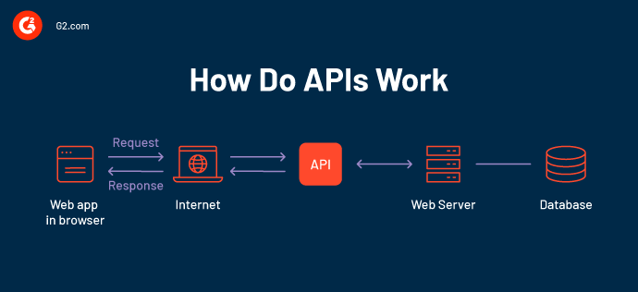

**What are common features of programming language.**

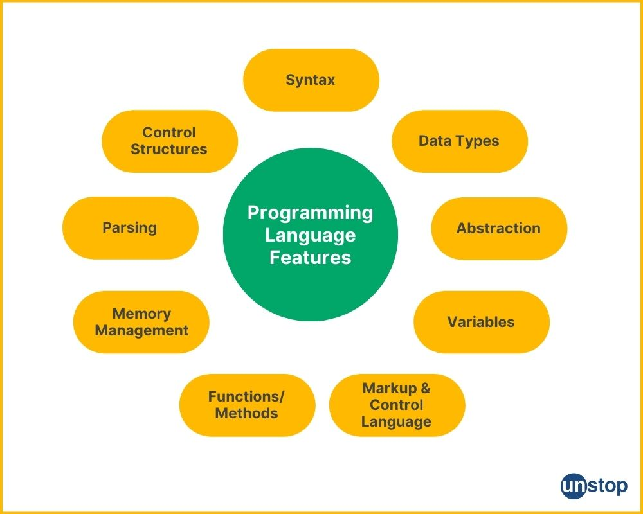

* **Syntax:**The specific guidelines and arrangement that computer languages employ to produce code.
* **Data Types:** the several types of values that may be kept in a program, including strings, integers, etc.
* **Variables**: Named memory locations that can store values.
* **Control Structures:** loops and conditional statements are examples of statements that regulate how a program executes.
* **Functions/Methods:** Blocks of code that can be called from other parts of a program to perform specific tasks.
* **Abstraction:** The ability to hide complex details and provide a simplified interface for users.
* **Memory Management:** The process of allocating and deallocating memory for variables and data structures.
* **Parsing**: The process of analyzing code to determine its structure and meaning.
* **Markup and Control Language:**The ability to add comments and other annotations to code to make it more readable and maintainable.